Liberia

## Political Stability Estimate Data

The data set shows the political stability estimate of the country each year.

## # A tibble: 19 x 5  
## country iso3c date stability stabilityCategory4   
## <chr> <chr> <dbl> <dbl> <chr>   
## 1 Liberia LBR 1996 -2.44 highly unstable   
## 2 Liberia LBR 1998 -1.75 highly unstable   
## 3 Liberia LBR 2000 -1.95 highly unstable   
## 4 Liberia LBR 2002 -2.19 highly unstable   
## 5 Liberia LBR 2003 -2.16 highly unstable   
## 6 Liberia LBR 2004 -1.37 highly unstable   
## 7 Liberia LBR 2005 -1.36 highly unstable   
## 8 Liberia LBR 2006 -1.33 highly unstable   
## 9 Liberia LBR 2007 -1.24 highly unstable   
## 10 Liberia LBR 2008 -1.29 highly unstable   
## 11 Liberia LBR 2009 -1.05 highly unstable   
## 12 Liberia LBR 2010 -0.469 moderately unstable  
## 13 Liberia LBR 2011 -0.427 moderately unstable  
## 14 Liberia LBR 2012 -0.484 moderately unstable  
## 15 Liberia LBR 2013 -0.476 moderately unstable  
## 16 Liberia LBR 2014 -0.615 moderately unstable  
## 17 Liberia LBR 2015 -0.818 moderately unstable  
## 18 Liberia LBR 2016 -0.437 moderately unstable  
## 19 Liberia LBR 2017 -0.411 moderately unstable

## Political Stability Estimate Plot

The plot shows the trends of stabilization and destabilization for the each country.

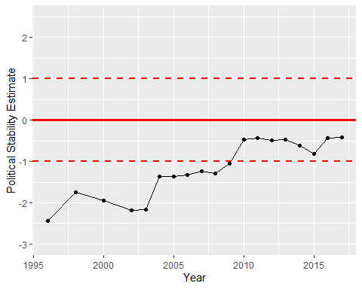

Political Stability Trend